A000-EUR-Bulgaria, Stara Zagora, Figurine-Tattooed-6th Millennium BCE-Neolithic

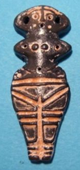

Fig. 1. Bulgaria, Stara Zagora, Figurine-Tattooed-6th Millennium BCE-Neolithic

**Formal Label:** Bulgaria, Stara Zagora, Figurine-Tattooed-6th Millennium BCE-Neolithic

**Accession Number:** A000

**Display Description:**

**Date or Time Horizon:** 6th millennium BCE

**LC Classification:** DR98 S83

**Geographical Area:** Stara Zagora, Bulgaria

**Map:**

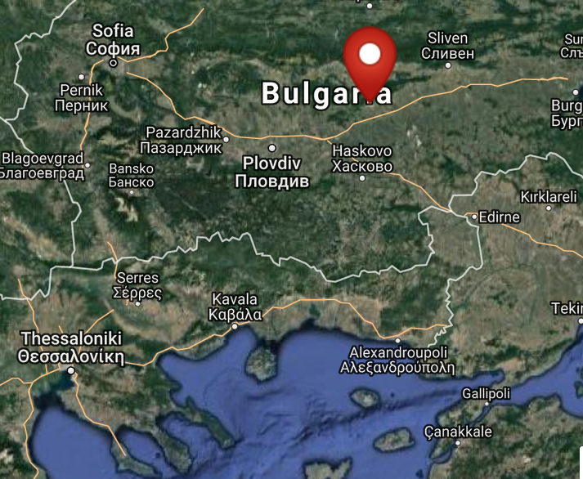

Fig. 2. Map of location of Stara Zagora, Bulgaria. From <http://latitude.to/lat/42.42604/lng/25.63356>

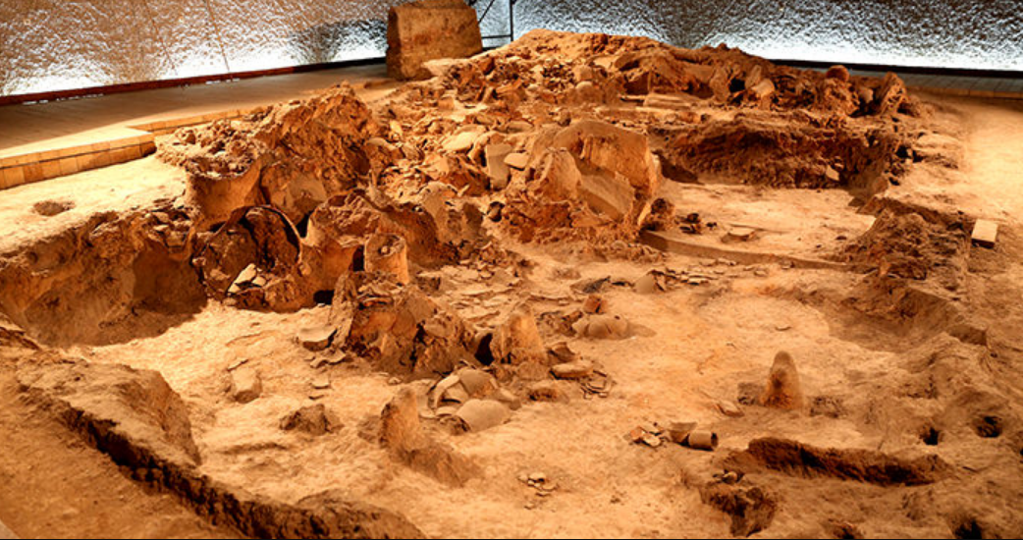

Fig. 3. Neolithic House, Stara Zagora regional Historical Museum, Bulgaria. http://www.getmetravelled.com/wp-content/uploads/2015/08/Neolithic-Dwellings-Museum_Stara_Zagora_Bulgaria.jpg

**GPS coordinates:** 42º25'33.74" N 25º38'0.81" E

**Medium:** black clay and red ochre

**Dimensions:**

**Weight:**

**Provenance:** Archaeological Museum in Stara Zagora

**Condition:** Museum Replica

**Discussion:** This figurine dates to the beginning of farming in central Europe and their red ochre geometric markings probably emulated the shape of tattoos or body paint. The production of ceramic figurines indicates that Stara Zagora was a sedentary society in which there was expendable time for producing amulets such as this for individuals.

**References:**

Fol, V. 1997. “The kouker without mask. The masquerade feasts in Southern Europe. Orpheus,” *Journal of Indo-European and Thracian Studies*, 7, pp. 83-99.

Gaul, James Harvey. [1948. *The Neolithic period in Bulgaria: early food-producing cultures of Eastern Europe*](http://www.worldcat.org/title/neolithic-period-in-bulgaria-early-food-producing-cultures-of-eastern-europe/oclc/1001170812&referer=brief_results)*.*  Cambridge (Mass.): Peabody Museum.

Grębska-Kulow, M. 2016. Prehistoric Anthropomorphic Figurines with Masks as the Basis for the Kuker’s Ritual in Bulgarian Folklore. In S. Biagetti and F. Lugli. eds, *The Intangible Elements of Culture in Ethnoarchaeological Research* (pp. 201-210). Springer International Publishing.

Hansen, Svend. 2007. *Bilder vom Menschen der Steinzeit: Untersuchungen zur anthropomorphen Plastik der Jungsteinzeit und Kupferzeit in Südosteuropa* / 1 Text. [Archäologie in Eurasien](http://www.worldcat.org/search?qt=hotseries&q=se%3A%22Archa%CC%88ologie+in+Eurasien%22), 20

Mainz: Von Zabern.

Hansen, Svend. 2007. [Bilder vom Menschen der Steinzeit : Untersuchungen zur anthropomorphen Plastik der Jungsteinzeit und Kupferzeit in Südosteuropa. T. 2, Tafeln](http://www.worldcat.org/title/bilder-vom-menschen-der-steinzeit-untersuchungen-zur-anthropomorphen-plastik-der-jungsteinzeit-und-kupferzeit-in-sudosteuropa-t-2-tafeln/oclc/749227731&referer=brief_results). [Archäologie in Eurasien](http://www.worldcat.org/search?qt=hotseries&q=se%3A%22Archa%CC%88ologie+in+Eurasien%22), 20

Mainz: Von Zabern.

Kalchev, Petŭr, Neicho Kanev and Lilia Philipova. 2004. *Stara Zagora, 8000 years: the genesis of Europe*. Stara Zagora: Zonta Club.

[Krauß](http://www.worldcat.org/search?q=au%3AKrau%C3%9F%2C+Raiko.&qt=hot_author), Raiko; [Nedko Elenski](http://www.worldcat.org/search?q=au%3AElenski%2C+Nedko.&qt=hot_author" \o "Search for more by this author); [Bernhard Weninger](http://www.worldcat.org/search?q=au%3AWeninger%2C+Bernhard.&qt=hot_author); [Lee Clare](http://www.worldcat.org/search?q=au%3AClare%2C+Lee.&qt=hot_author); [Canan Çakirlar](http://www.worldcat.org/search?q=au%3AC%CC%A7akirlar%2C+Canan.&qt=hot_author" \o "Search for more by this author); [Petǎr Zidarov](http://www.worldcat.org/search?q=au%3AZidarov%2C+Peta%CC%8Cr.&qt=hot_author" \o "Search for more by this author). 2014. “Beginnings of the Neolithic in Southeast Europe: the early Neolithic sequence and absolute dates from Džuljunica-Smǎrdeš (Bulgaria),” *Documenta Praehistorica. Poročilo o raziskovanju paleolitika, neolitika in eneolitika v Sloveniji. Neolitske študije = Neolithic studies*, 41:51-77.

Perničeva, L. 2004. Anthropozoomorphe Figurinen aus dem späten neolithikum in Südwestbulgarien. In V. Nikolov & K. Băčvarov, eds., Von Domica bis Drama. Gedenkschrift für Jan Lichardus. (pp. 59–67). Sofia.

Todorova, Khenrieta. 1978. *The Eneolithic period in Bulgaria in the fifth millennium B.C*. Oxford: British Archaeological Reports.